ECE6372 Final Project Proposal

Team name: FireMuray

Team members: Qiyu Wan (Leader), Jiajun Chang, Meiqi Xia

Title: FPGA Implementation of a Simple Convolutional Neural Network for Image Recognition

Project description:

This project implements LeNet-5(shown in figure 1), a simple convolutional neural network (CNN), on an Altera DE-10 Lite development board for handwritten digit recognition (shown in figure 2).

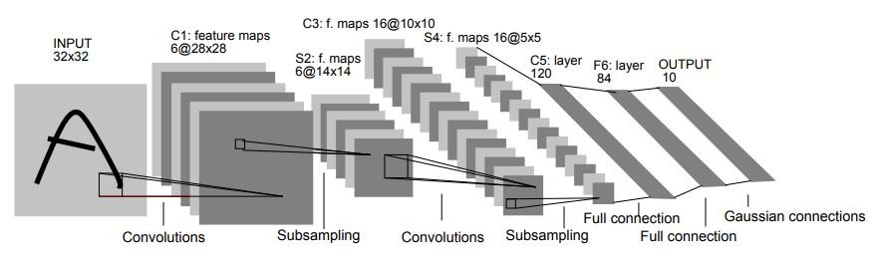

Figure 1. LeNet-5 Structure [1]

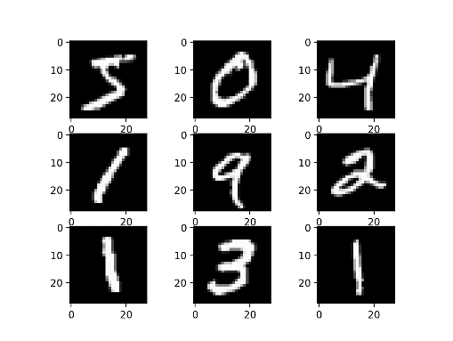

Figure 2. MNIST dataset: handwritten digit recognition [2]

Our system will include following components: host-to-device communication, memory interface, convolution buffer and processing engine (Multipliers and adders). In this application, the image data will be transferred from PC to SDRAM beforehand. Once the system starts, input data will flow from SDRAM to on-chip buffer through memory interface. Then processing unit will fetch data from buffer and calculate the results, which will be sent back to SDRAM. Finally the LED will display the output (single digit) recognized from this image.

In this project, we will use Intel Quartus® Prime as software development tool and ModelSim-Altera as simulation tool. We will use Altera DE-10 Lite as the only hardware.

Reference:

[1]<https://engmrk.com/lenet-5-a-classic-cnn-architecture/>

[2]<https://machinelearningmastery.com/how-to-develop-a-convolutional-neural-network-from-scratch-for-mnist-handwritten-digit-classification/>

Please describe the application and system your team will be developing. Describe how the DE10-Lite board will be used (briefly). State what additional hardware/software/mobile devices you will use/purchase for the project. The mini-proposal should be about half a page long as we might change the topic/implementation during the discussions.